W9 PRACTICE
Authentication(JWT) & Secure Storage

 Learning objectives
- Build the User and AuthSession model
- Build a JWT authentication service
- Build a Login screen and validate the inputs
- Implement the user flow to login and logout by connecting to the Authentication service
- Store and read the token in/to Flutter secure storage

How to submit?
- Push your final code on your GitHub repository
- Then attach the GitHub path to the MS Team assignment and turn it in

 Before practice, to be prepared!
Read the following documentation to be ready for this practice:

https://pub.dev/packages/jwt_decoder/example
https://www.jwt.io
https://www.base64decode.org
https://pub.dev/packages/http

Build a Flutter Authentication App

For this exercise, you will need to handle the authentication of user and manage the navigation between the views:

- Build the authentication service and the auth session model (token and user object)
- Build the screens (authentication and welcome screen)
- Handle the navigation depending on the authentication status
- (NICE) Handle the persistency of the JWT token in Flutter Secure storage

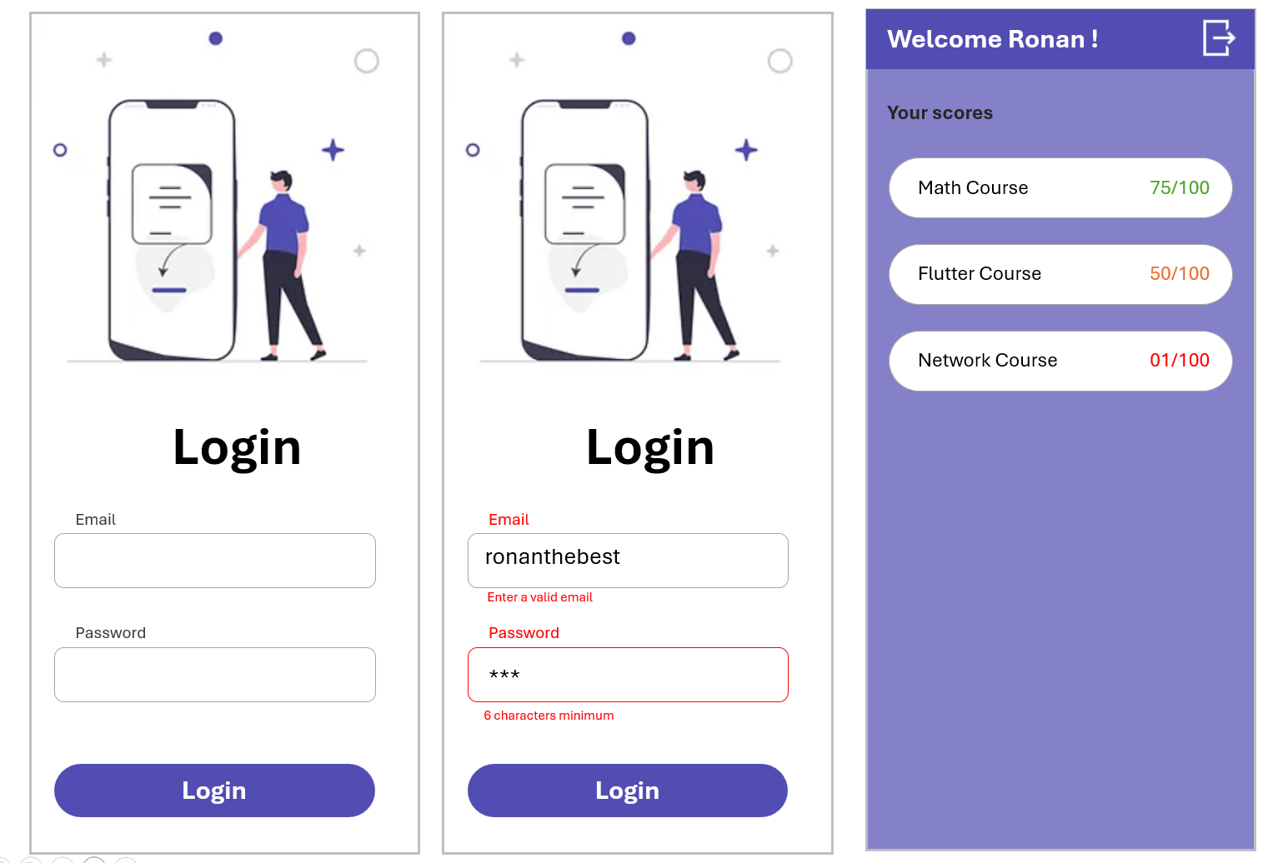

STEP 1 – Run the simulated server on localhost

💡The server code is provided

We need to run a small Node Express Server (provided) in /server folder:

Install node modules packages:

npm install

Run the server:

node .\server.js

📄SERVER API DOCUMENTATION

1. Login
POST /login
Authenticate a user and return a JWT token.

Request
{
"name": "john",
"password": "1234"
}

Response
{
"token": "JWT_TOKEN",
"user": {
"id": 1,
"name": "john",
"role": "student"
}
}

2. Get All Scores
GET /scores
Returns all scores.

Headers
Authorization: Bearer JWT_TOKEN
Response
[
{
"id": 1,
"userId": 1,
"title": "Flutter Quiz",
"score": 85
}
]

3. Get Scores by User
GET /scores/user/{userId}
Returns scores for a specific user.

Headers
Authorization: Bearer JWT_TOKEN

Example
GET /scores/user/1

Response
[
{
"id": 1,
"userId": 1,
"title": "Flutter Quiz",
"score": 85
}
]

STEP 2 – Build the authentication service and models

💡Start code provided

The flutter app is provided with the bellow structure

/data

/dto // json to model objects
scores_dto.dart
user_dto.dart

/repositories
scores_repository.dart // handle scores api

/services
auth_services.dart // handle authentication service

/model
user.dart
score.dart

/ui/screens
authentication_screen.dart
scores_screen.dart
app_screen.dart // navigate btw authentication/score screens

main.dart

TODO:

- Adapt the user model to handle user id, name and expiration date
- Adapt the user DTO to handle user id, name and expiration date

- Adapt the authentication service to:
  - Login with email and password (right now, only name)
  - Logout (remove the token and authentication session

- Create the score repository to fetch the list of scores:

Future<List<Score>> getScores(String accessToken);

💡 Note : The repository does not know about Authentication Service, it just receives the authentication token it needs from its caller.

final session = AuthenticationService.instance.session;
final scores = await scoreRepository.getScores(session.token);
Example of call with the token passed to the repository

STEP 3 – Build the authentication and welcome screen

💡Start code provided

LOGIN SCREEN
The login screen is provided with
- The image centered
- The 2 textfield
- The login button

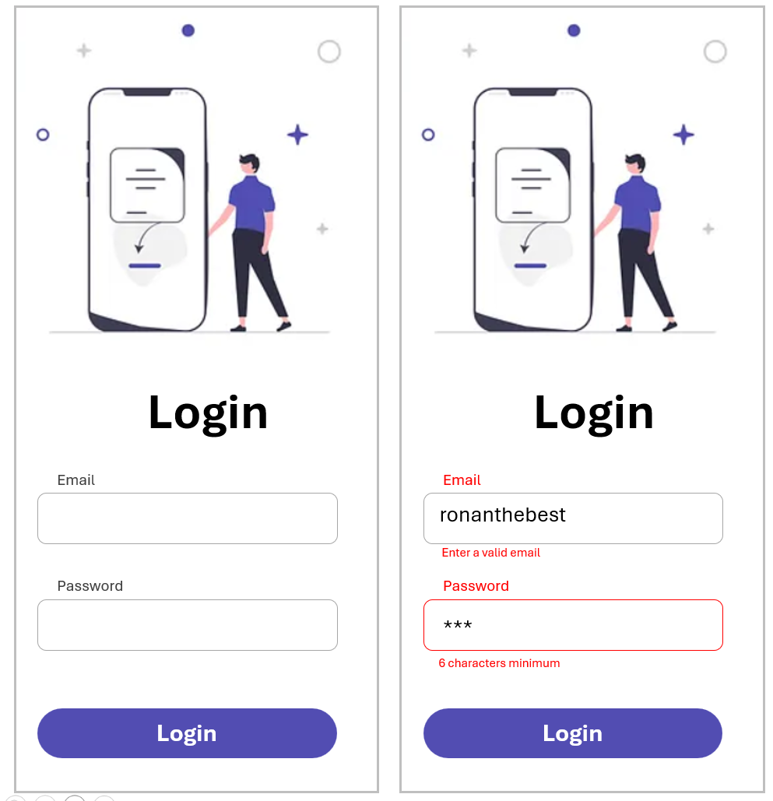
TODO

- Handle the validation of the 2 textfield:
  - The email shall be a valid email syntax
  - The password shall be strong (6 characters, 2 upper cases, 2 special characters)

- Pass a callback when the login action is submitted

SCORES SCREEN

💡Start code provided

The scores screen is provided with
- A fake list of scores displayed within a ListView and score cards
- The app bar
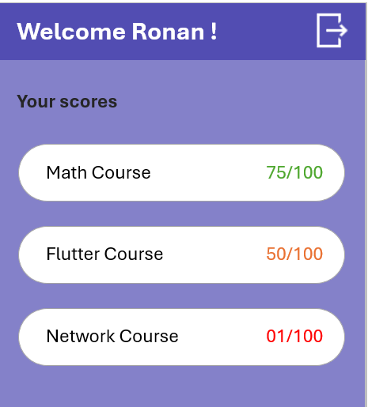

TODO

- Pass the Username to the screen and display it on the app bar (Welcome XX)
- Pass the list of scores to be displayed

- Pass a callback when the logout action (app bar button) is submitted

APP SCREEN

💡Start code provided

TODO

- Create the app screen which either displays the authentication or the score screen depending on a state (enum)

- Implement the callback (onLoggin + onLogout) :
  - For now, just update the authentication state and refresh the view

- Test :
  - We display the authentication screen first
  - When clicked on login button we display the score screen
  - When clicked on logout we display the authentication screen again

STEP 4 – Handle the navigation depending on the authentication status

💡Start code provided

It’s now time to link the authentication service with the screen’s behavior!

TODO

- IN the app screen, create a getter to provide the Widget content, depending on the authentication state
  - If user is authenticated, display the score screen
  - Otherwise display the auth screen

